EPC
Quotation Building
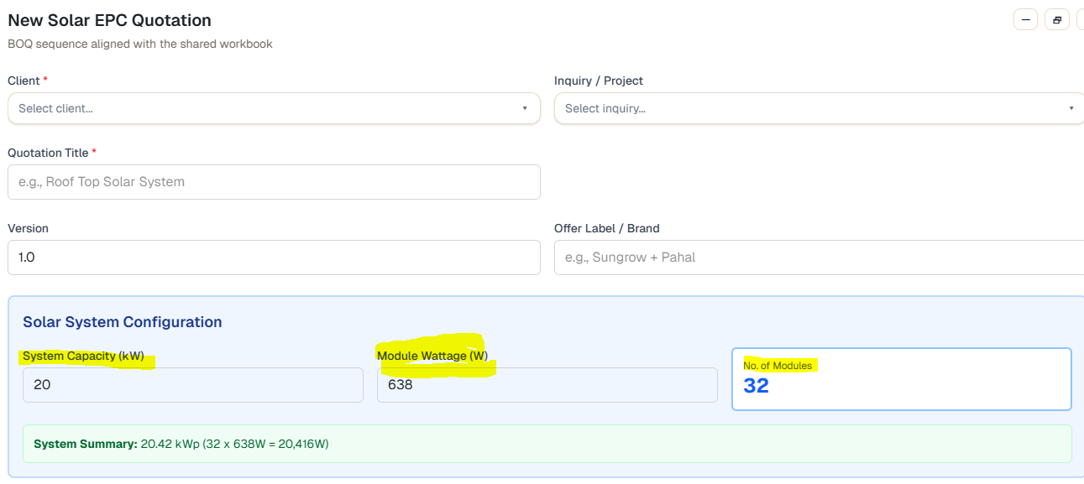
Solar System Configuration
Field | Data
Module Wattage | User Input
No of Module | User Input
Total WP | [Module Wattage * No of Module]
Total KW | [Total WP / 1000 ]

Type of Consumer ( Dropdown to select one)
LT Consumer
HT Consumer

